AABE Atlanta celebrates Dr. Martin Luther King, Jr. holiday with program featuring Elisabeth Williams-Omilami
By Delitha Morrow Coles
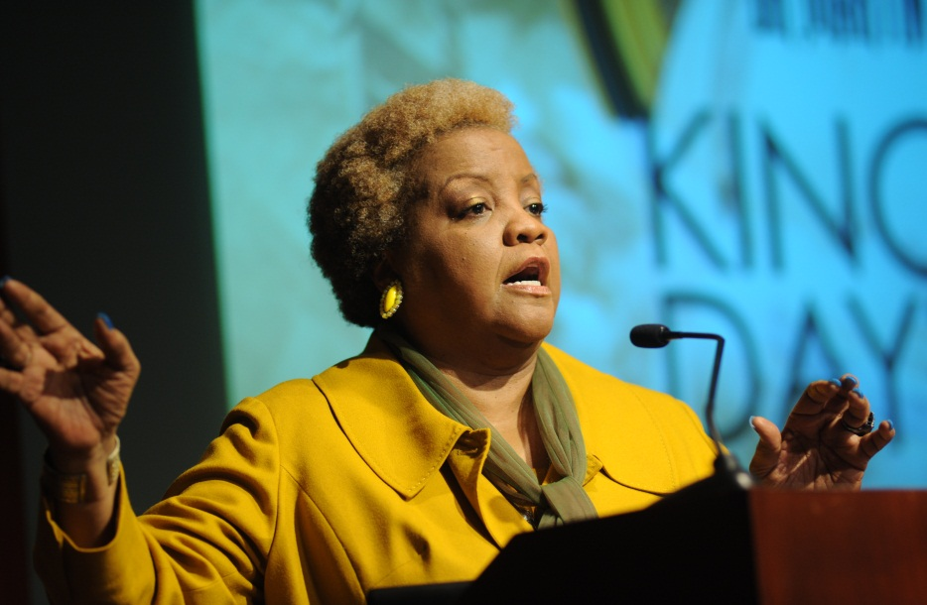
The Atlanta Chapter of the American Association of Blacks in Energy® (AABE) celebrated the legacy of Dr. Martin Luther King, Jr. on what would have been his 85th birthday by co-hosting a program reminding participants of the importance of helping others. Sharing this message was Elisabeth Omilami, daughter of noted civil rights leader Dr. Hosea Williams, and CEO, Hosea Feed the Hungry & Homeless, an organization that provides goods and services for Atlanta’s homeless and others in need of life’s basic necessities.
The program opened with a poetry reading from Jovanay C., an 11th grade student from the local Coretta Scott King Youth Women’s Leadership Academy, who spoke rhythmic words about being “blessed to hear the bells of freedom ringing louder and louder in [her] ear” and a melody from the Martin Luther King Jr. High School chorus, who told us they believed they could fly.
Newly installed Chapter president, Rodney Russell, reintroduced the AABE organization and welcomed audience members from Georgia Power, AGL Resources, Georgia Natural Gas, SCANA Energy and GE. Russell then shared the organization’s mission and goals, and he introduced guest speaker Omilami.
“AABE exists to help educate people about important energy issues, especially those affecting people of color,” said Russell. “I was delighted to see the standing-room-only crowd participate in the shared mission of AABE and the Hosea Feed the Hungry organization to invest in our community.”
Mrs. Omilami also shared sobering statistics illustrating the deep poverty that exists in Atlanta, adding that Atlanta is first in the nation for child poverty and 36th for long-term unemployment. She says she went to jail three times before the age of 9 so that she could see her father. From him she learned persistence and the value of helping those in need.

“You’re not only here to create wind and solar; that’s on the side,” Omilami said, jokingly. “You’re here because you have the power to act. You’re AABE because you’re able. You can make a difference.”

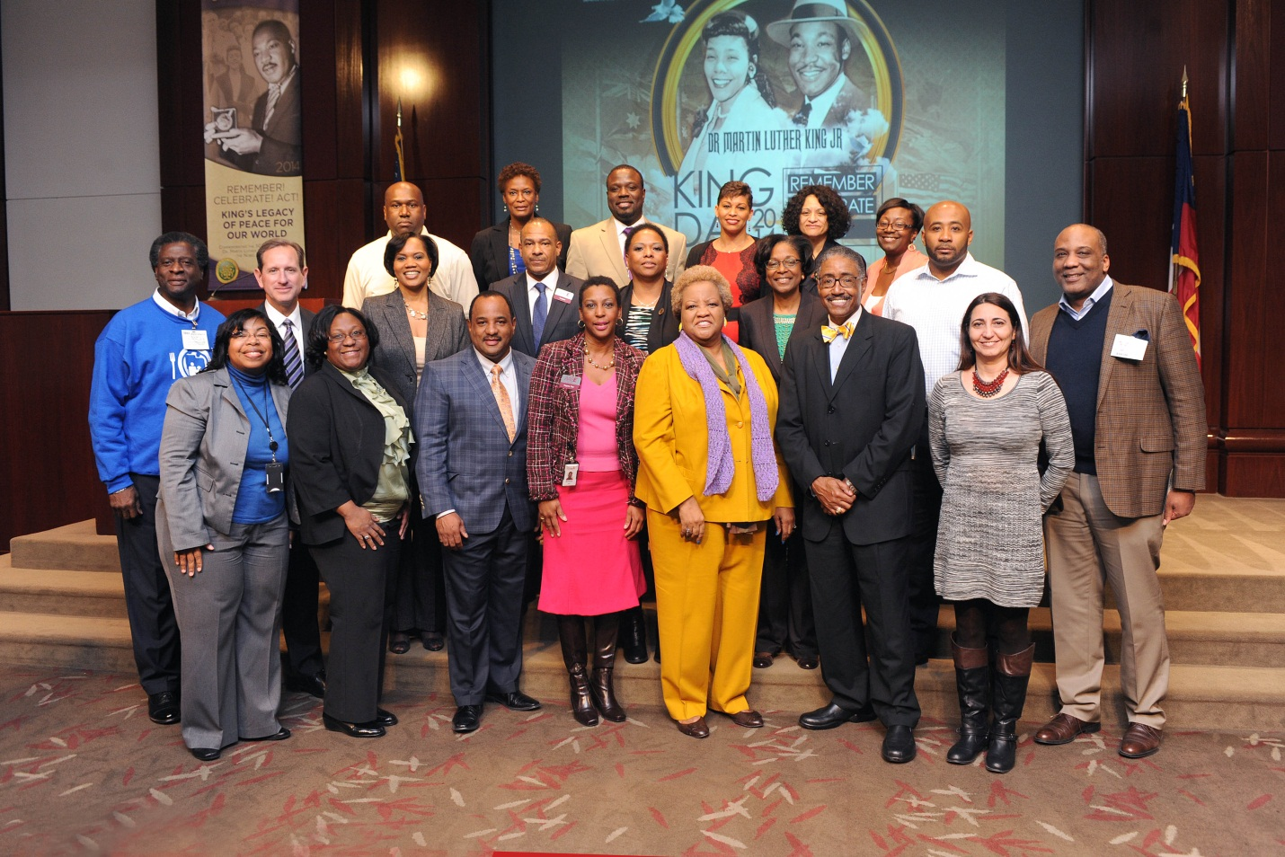
Omilami said that at times growing up the child of a Civil Rights pioneer was like “growing up in a war.” Her father was often away; their home was a frequent target of hurled bricks and geometric fires, and sometimes she was afraid to sleep at night.
Still, her instinct to serve was more powerful than those threats and endured. In sharing her personal struggle, she encouraged the audience to always think of others first, much in the same way Dr. Martin Luther King, Jr. did.
She closed by sharing a line from one of her favorite writings, which clearly drives her passion for helping others in need. It’s from Lorraine Hansberry’s A Raisin in the Sun:
“Child, when do you think is the time to love somebody the most? When they done good and made things easy for everybody? Well then, you ain't through learning - because that ain't the time at all. It's when he's at his lowest and can't believe in hisself 'cause the world done whipped him so!”

